PO - AP Interface
Oracle EBS R12.2 — Receipt-to-Invoice & RTV-to-Credit-Memo Interface

Version: 1.1 | Date: April 2026 | Environment: Oracle EBS R12.2

1. Project Overview
This project implements a data migration and automated interface between a legacy Oracle EBS instance and a new Oracle EBS instance. It covers three main areas: PO receipt-to-invoice automation, supplier master data migration, and Chart of Accounts (COA) segment mapping.

1.1 Components
- PO-AP Receipt Interface (PO_AP.sql): PL/SQL package XXCUST_PO_AP_INTERFACE_PKG. Reads confirmed PO receipts from the legacy instance and creates AP invoices and credit memos in the new instance via the AP open interface tables.
- Supplier Migration (migrate_supplier.sql): Migrates AP_SUPPLIERS, AP_SUPPLIER_SITES_ALL, AP_SUPPLIER_CONTACTS, bank accounts, payment instruments, and external payees across a DB link (LEGACY_INSTANCE).
- COA Segment Mapping (Segment_mapping.sql): Creates mapping tables that translate legacy COA segments (Division, Product, Department, Account) to the new instance's structure: Entity.Division.Account.Department.Product.TxnType.

- Node.js Scheduler (run_po_ap_interface.js): Automates daily execution of Process A, Process B, and log purge. Connects via oracledb (optionally through an SSH tunnel), captures DBMS_OUTPUT, and writes timestamped log files.

2. PO-AP Interface — Process Details

2.1 Process A — Receipt-to-Invoice
Process A reads RECEIVE transactions from the legacy RCV_TRANSACTIONS table. For each unbilled PO release (quantity_billed < quantity_ordered), it nets off any Return-to-Vendor (RTV) quantities and creates a STANDARD AP Invoice in the new instance via AP_INVOICES_INTERFACE and AP_INVOICE_LINES_INTERFACE. Tax lines (CGST/SGST) are derived from the PO line tax category.
- No receipt = No invoice (only RECEIVE transactions trigger invoice creation).
- Net quantity = RECEIVE qty − RTV qty (RTVs that occur before invoice creation are netted).
- Duplicate prevention: invoice_num checked against existing AP_INVOICES_INTERFACE records.
- COA derivation: CCID resolved from segment mapping tables (Division, Product, Department, Account).
- Invoice number format: RCPT-{receipt_id}-L{line_number_padded}.

2.2 Process B — RTV-to-Credit-Memo
Process B handles RTVs that occur after an invoice has already been created by Process A. For each such RTV, a CREDIT type invoice (credit memo) is created with negative amounts. The credit memo references the original invoice in its description.
- Scenario A: RTV before any receipt — skipped (no invoice exists to credit).
- Scenario B/C: RTV after invoice created — CREDIT memo generated.
- Credit memo number format: CM-{original_invoice_num}.
- All line amounts are negative; tax lines mirror the original invoice tax structure.

3. Test Case — PO 5985471
The following test case validates the end-to-end flow for a BLANKET PO with 5,558 releases, 104 lines, and one Return-to-Vendor on Line 75.

3.1 Test Metadata
Field | Value
PO Number | 5985471
PO Type | BLANKET
Vendor ID / Site ID | 13001 / 14023
Currency | INR
Legacy PO Header ID | 6443887
Test Date | 29-Apr-2026
Process A Run ID | INV-20260429122004
Process B Run ID | RTV-20260429122055
Total Releases | 5,558 across 104 lines
Unbilled Releases with Receipts | 35
RTVs | 1 (Line 75, qty=10, 02-Apr-26)

3.2 Summary Results
Metric | Expected | Actual | Match?
Process A: Invoices processed | 35 | 35 | ✓
Process A: Total invoice amount (INR) | 1,608,217.37 | 1,608,217.37 | ✓
Process A: Rejected | 0 | 0 | ✓
Process A: Skipped | 0 | 0 | ✓
Process B: Credit Memos processed | 1 | 1 | ✓
Process B: Credit Memo amount (INR) | 74.66 | 74.66 | ✓
Process B: Skipped (Scenario A) | 0 | 0 | ✓
Net AP Balance (INR) | 1,608,142.71 | 1,608,142.71 | ✓

3.3 Key Scenario — RTV Net Quantity (Line 75)
Line 75 (KODUBALE 30 GM, line_location_id = 14796453) had a RECEIVE of 1,500 units on 01-Apr-2026 followed by an RTV of 10 units on 02-Apr-2026. Process A correctly netted the quantity:
Item | Value
RECEIVE quantity | 1,500
RTV quantity (netted) | 10
Net invoiced quantity | 1,490
Unit price | 7.11
ITEM line amount | 10,593.90
CGST 2.5% | 266.63
SGST 2.5% | 266.63
Total invoice amount | 11,127.16
Invoice number | RCPT-6797774-L075

3.4 Credit Memo for Post-Invoice RTV (Process B)
Since the RTV on Line 75 occurred after Process A created the invoice, Process B generated a credit memo CM-RCPT-6797774-L075 with the following amounts:
Item | Value
Credit Memo number | CM-RCPT-6797774-L075
Type | CREDIT
RTV quantity | 10
ITEM line amount | -71.10
CGST tax line | -1.78
SGST tax line | -1.78
Total credit memo amount | -74.66
CCID | 5028

4. Screenshots — Interface Execution Evidence
The following screenshots document the state of the Oracle AP interface tables and production tables before and after running the PO-AP interface script and the AP Import concurrent program.
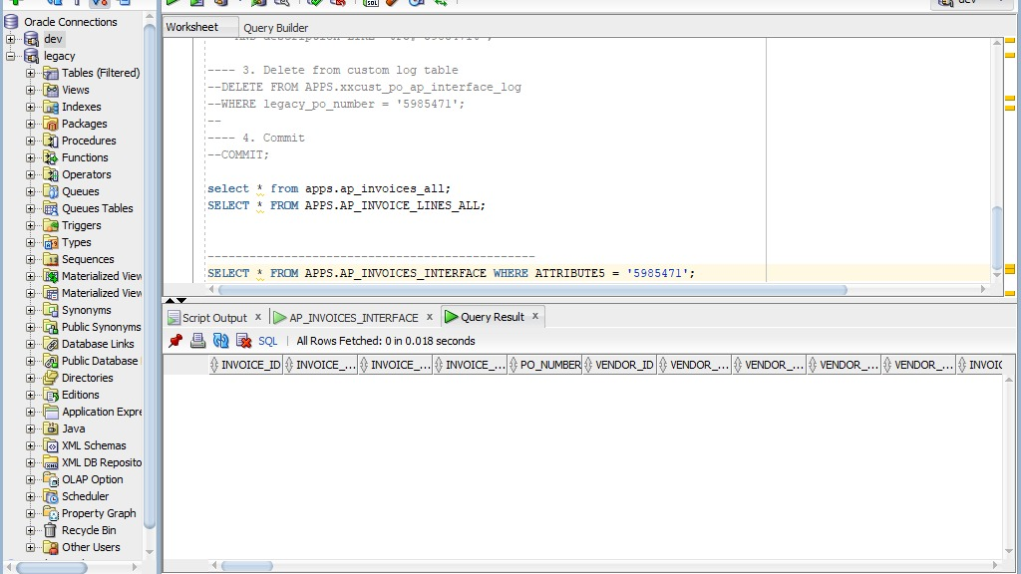
Before Running Script — Initial state of AP_INVOICES_INTERFACE table before the PO-AP interface script is executed. Shows empty or baseline records.

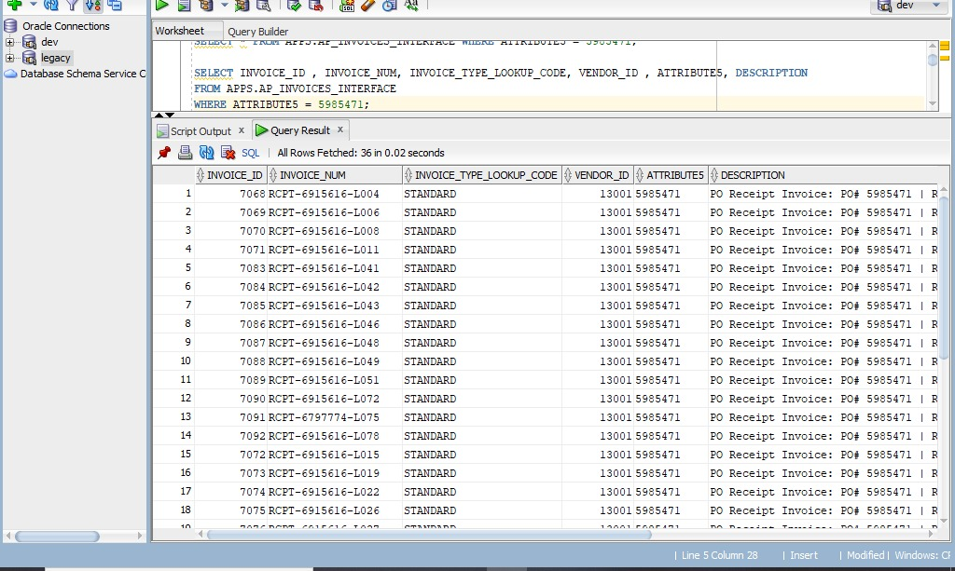
After Running Script — AP_INVOICES_INTERFACE — Records inserted into AP_INVOICES_INTERFACE after Process A (Receipt-to-Invoice) runs. Each row represents a STANDARD invoice header staged for import.

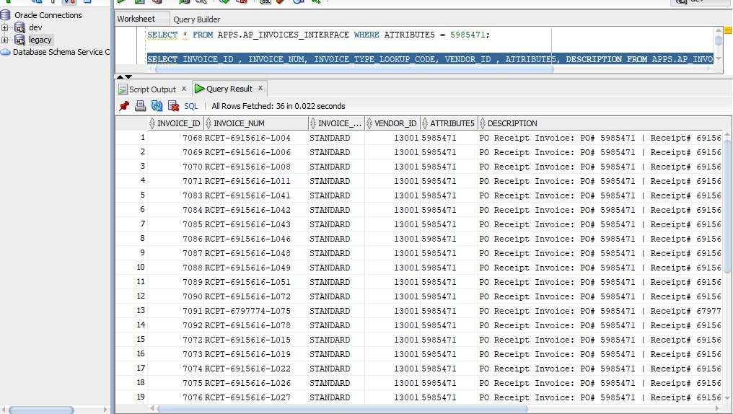
After Running Script — AP_INVOICES_INTERFACE (Detail View) — Detailed view of the AP_INVOICES_INTERFACE staging table after script execution, showing invoice numbers, amounts, vendor details, and status.

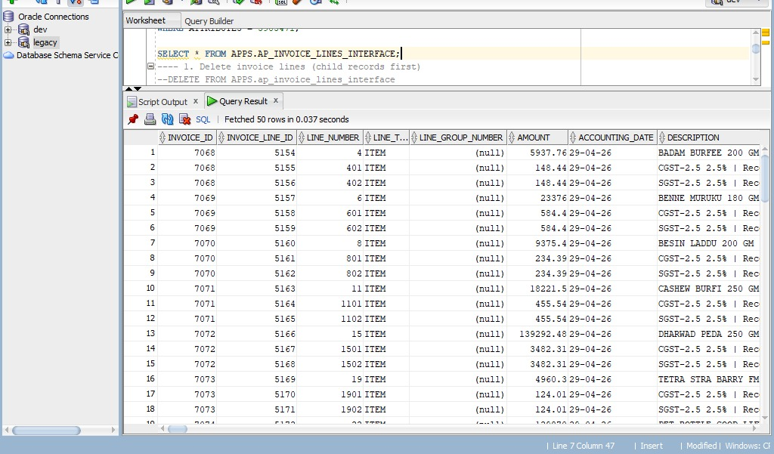
After Running Script — AP_INVOICE_LINES_INTERFACE — Invoice line records staged in AP_INVOICE_LINES_INTERFACE after Process A. Includes ITEM lines and tax lines (CGST/SGST) for each invoice.

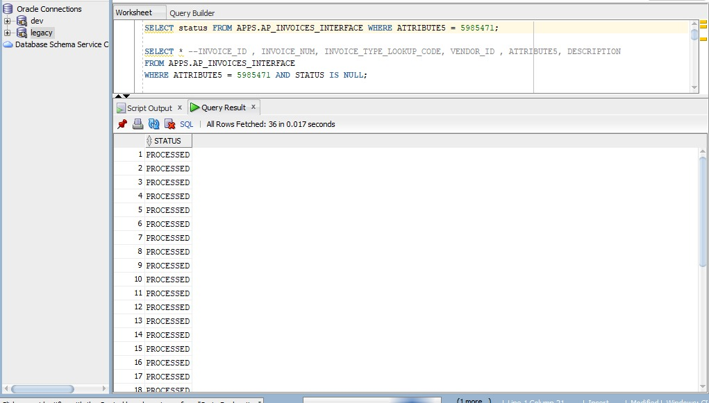
Status After Running AP Import Program — Status of the AP Import concurrent program after execution. Shows the import job completion status and any errors or warnings.

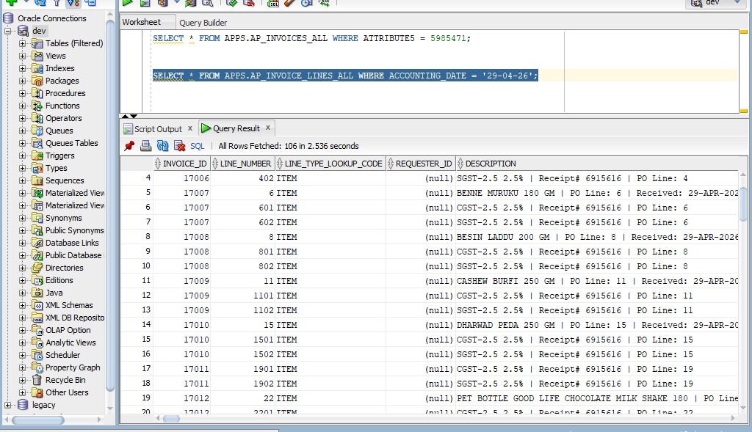
After Running AP Import Program — AP_INVOICE_LINES_ALL — Final state of AP_INVOICE_LINES_ALL after the AP Import program processes the interface records. Invoices are now fully created in Oracle AP.

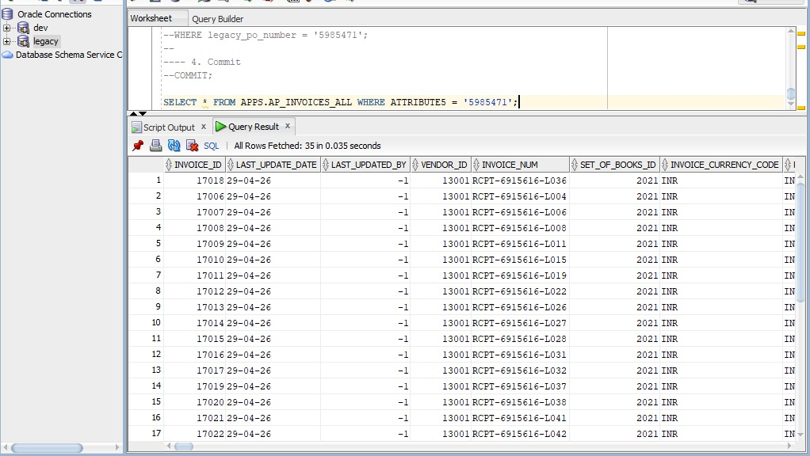
After Running AP Import Program — AP_INVOICES_ALL — Final state of AP_INVOICES_ALL showing the imported invoices. Records moved from interface tables to production AP tables with validated status.

5. Scheduler Configuration
The Node.js scheduler (run_po_ap_interface.js) automates daily execution. It supports multiple Oracle connection profiles and optional SSH tunneling for remote database access.
- Default schedule: Daily at 02:00 AM (configurable via crontab).
- Connection: oracledb with optional SSH tunnel via ssh2.
- Log files: Written to script/logs/ with timestamp format po_ap_interface_YYYYMMDDHHMMSS.log.
- Log retention: Configurable purge of logs older than N days.
- Config file: script/config.json (based on config.json.example).

6. Chart of Accounts Structure
The new Oracle EBS instance uses a six-segment COA structure. Segment values are derived from mapping tables populated by Segment_mapping.sql.
Segment | Description | Mapping Source
Entity | Legal entity identifier | Fixed / config
Division | Business division | organization_id → XXCUST_DIVISION_MAP
Account | Natural account | Account mapping table
Department | Cost center / department | Department mapping table
Product | Product/item segment | inventory_item_id → XXCUST_PRODUCT_MAP
TxnType | Transaction type | Derived from PO transaction type

5. EBS UI Verification — Processed Invoices (Test Case PO 5985471)
The following screenshots are taken directly from the Oracle EBS Accounts Payable module after the AP Import concurrent program completed. They confirm that the invoices staged by the PO-AP interface script were successfully created in the production AP tables and are visible in the EBS UI.

EBS UI — Standard AP Invoice (Process A Result)
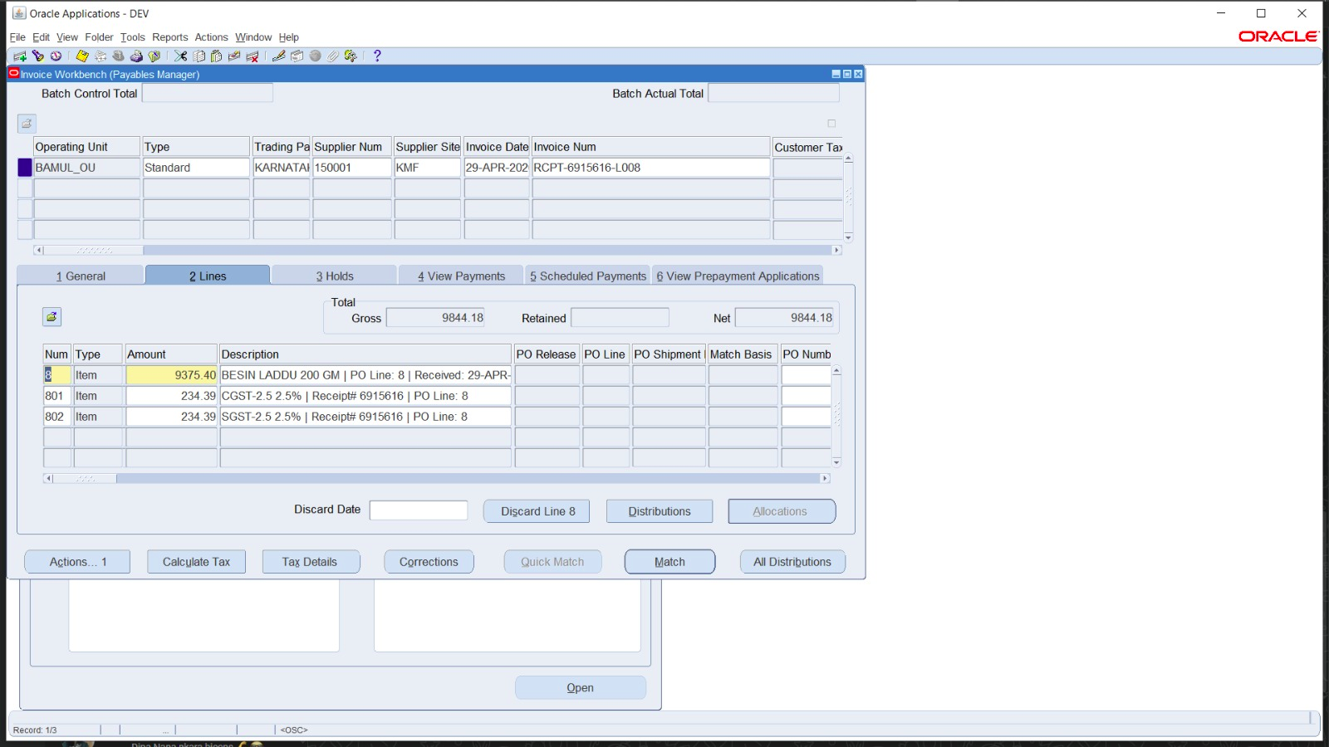
Oracle EBS Accounts Payable UI showing the processed Standard invoice created by Process A for PO 5985471. The invoice reflects the net receipt quantity after RTV netting, with ITEM and tax (CGST/SGST) lines, and has been successfully imported via the AP Import program.

EBS UI — Return / Credit Memo Invoice (Process B Result)
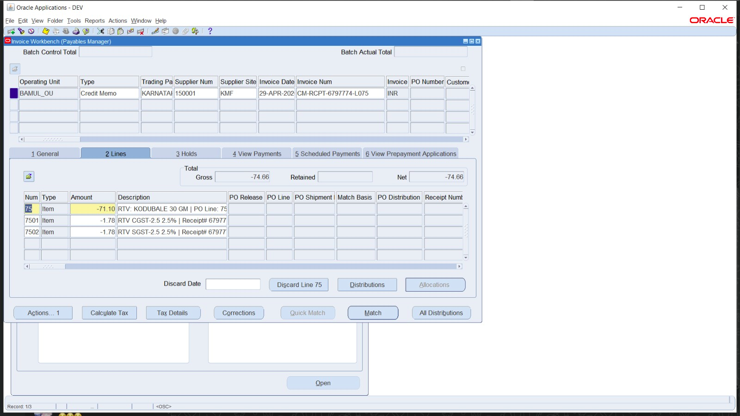
Oracle EBS Accounts Payable UI showing the Credit Memo (CM-RCPT-6797774-L075) created by Process B for the Return-to-Vendor on Line 75 of PO 5985471. The invoice type is CREDIT, all line amounts are negative, and the memo references the original Standard invoice.

